
UT/GEQP/1223/A 09-NOV-2023
UNIT TEST (2023-24)
Subject: GEOGRAPHY  Grade: XII |  | Max. Marks: 50  Time: Hours
GENERAL INSTRUCTIONS
I. Question paper is divided into 5 sections A, B,C,D&E
II. In section A question number 1 to 12 are objective type questions.
III. In section B question 13 is Source based questions.
IV. In section C question number 14 to 17 are Short Answer based questions.
V. In section D question number 18 to 20 are Long Answer based questions.
VI. In section E question number 21and 22 are Map based question.
SECTION A
(OBJECTIVE TYPE QUESTIONS)
1. | Why cannot products of gathering compete in the world market? |  | 1
 | (a) Close market concept | (b) Availability of less price synthetic products
 | (c) Use of old technology | (d) None of the Above
2 | The open-cast mining is the easiest and the _________ way of mining minerals |  | 1
 | (a) useless | (b) expensive
 | (c) cheapest | (d) admirable
3. | Arrange the countries from the highest to the lowest on total road network :  (i) United States of America (ii) India (iii) China (iv) Brazil |  | 1
 | (a) i, ii, iii, iv
 | (b) iv, ii, iii, i
 | (c) iii, iv, i, ii
 | (d) i, iii, ii, iv
4. | ____________ is a powerful medium of collecting information from the computer. |  | 1
 | (a) Satellite | (b) Internet
 | (c) Television | (d) Laptop
5 | _________ is an information system where documents and other web resources are identified by Uniform Resource Locators, which may be interlinked by hyperlinks, and are accessible over the Internet. |  | 1
 | (a) Worldwide wed | b) World wide web
 | (c) Worldwide world | (d) Worldwide watch

6 | Assertion (A): Transport is a service or facility for the carriage of persons and goods  from one place to the other using humans, animals and different kinds of vehicles.  Reason (R): Such movements take place over land, water and air |  |  | 1
Directions: In the following questions,
A statement of Assertion (A) is followed by a statement of Reason (R).
Mark the correct choice as:
(A) Both A and R are true and R is the correct explanation of A.
(B) Both A and R are true but R is NOT the correct explanation of A.
(C) A is true but R is false.
(D) A is false and R is true.
7 | Which one pair of the following places is linked by Channel Tunnel? |  |  | 1
 | (a) London- Berlin |  | (b) Berlin -Paris
 | (c) Paris- London |  | (d) Barcelona- Berlin
8 | The terminal points of North- South Corridor are: |  |  | 1
 | (a) Srinagar to Kanyakumari |  | (b) Jaisalmer to Silchar
 | (c) Delhi to Chennai |  | (d) Amritsar to Bangalore
9 | ------------------ is the largest government undertaking in India. |  |  | 1
 | (a) Air India |  | (b) National waterways
 | (c Indian Railways |  | (d) Pipelines
10 | Which of the following is NOT a land -use category? |  |  | 1
 | (a) Fallow land |  | (b) Marginal Land
 | (c) Net sown area |  | (d) Culturablewaste land
11. | ________ is a short duration summer cropping season. |  |  | 1
 | (a)zaid | (b)rabi
 | (c)kharif | (d)none of the above
12. | Which of the following crop is sown under both kharif and rabi season in southern India |  |  | 1
 | (a) Maize |  | (b) Pulses
 | (c) Bajra |  | (d) Jowar
SECTION B
SOURCE BASED QUESTION
13 | Read the case study given below and answer the questions that follow:  Depending on the mode of occurrence and the nature of the ore, mining is of two types: surface and underground mining. The surface mining also known as open-cast mining is the easiest and the cheapest way of mining minerals that occur close to the surface. Overhead costs such as safety precautions and equipment are relatively low in this method. The output is both large and rapid. When the ore lies deep below the surface, underground mining method (shaft method) has to be used. In this method, vertical shafts have to be sunk, from where underground galleries radiate to reach the minerals. Minerals are extracted and transported to the surface through these passages. It requires specially designed lifts, drills, haulage vehicles, ventilation system for safety and efficient movement of people and material. This method is risky. Poisonous gases, fires, floods and caving in lead to fatal accidents. The developed economies are retreating from mining, processing and refining stages of production due to high labour costs, while the developing countries with large labour force and striving for higher standard of living are becoming more important. Several countries of Africa and few of south America and Asia have over fifty per cent of the earnings from minerals alone
13.1 | What is the other name of surface mining? |  | 1
13.2 | Which type of mining uses the method of excavating a vertical or near-vertical tunnel from the top down, where there is initially no access to the bottom? |  | 1
13.3 | Why developed economies are retreating from mining, processing and refining stages of production? |  | 1
SECTION C
SHORT ANSWERS
14. | Write a brief note on Co-operative farming. |  | 3
15. | Observe the given map and answer the following questions:  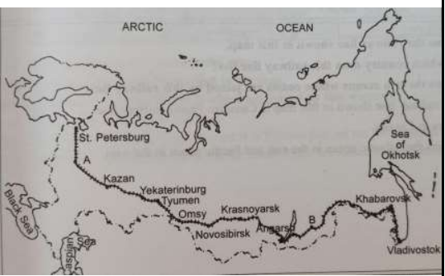 |  | 3
1) Name the Railway line and name the country where it lies.
2) Name the stations marked as A and B.
3) State two reasons why it is the most important route in Asia?
16. | Write a note on any three National Waterways in India. |  | 3
17. | Why is the strategy of increasing cropping intensity important in a country like India? |  | 3
SECTION D
LONG ANSWERS
18. | What is ‘Truck Farming’? Name the countries which practice it . List 3 characteristics for the same. |  | 1+1+3
19. | Describe the role of roads in the economic development of India. |  | 5
20. | State the drawbacks of agriculture present in India. |  | 5
SECTION - E
MAP QUESTIONS
21 | Identify the following on the political map of the world.  A. Name the shipping canal between North and South America  B. Name the busiest international airport of Germany  C. Name the important airport of Australia.  D. Name the major airport in Japan |  | 4
22 | On the outline map of India indicate and mark the following features (any 4)  1) Kandla Port  2) Kochi Port  3) An international airport in Maharashtra  4) Delhi International airport  5) A major port in west Bengal |  | 4

NAME: SEC: ROLL:

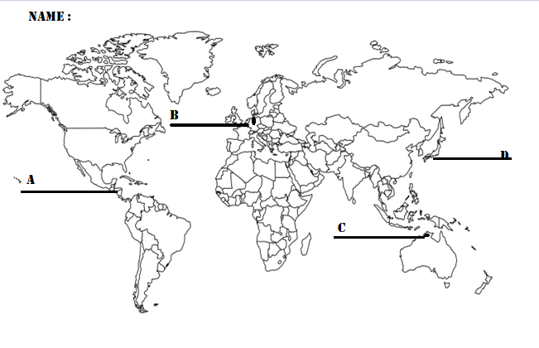

NAME: SEC: ROLL:

